

SOCIAL MEDIA TOURISM CAPSTONE PROJECT

NOTES - II

Submitted To: Concerned Faculty At
Great Learning
The University of Texas at Austin

Submitted By:
Rachit Mittal PGPDSBA online July E 2020

Laptops

Logistic Regression Training Set

Fig 1
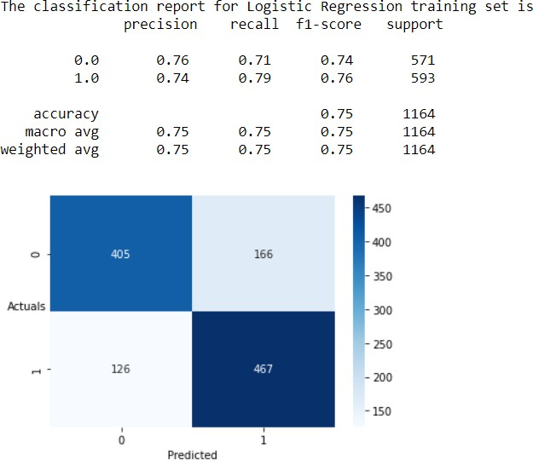

Fig 2
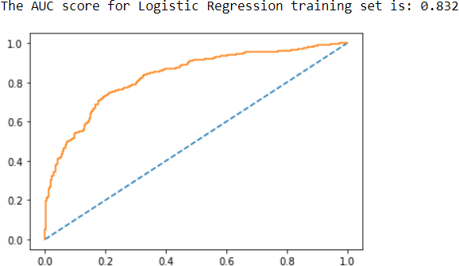

Fig 3

Fig 4
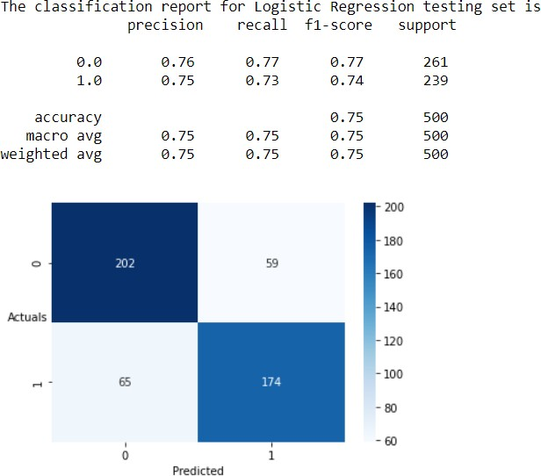

Fig 5

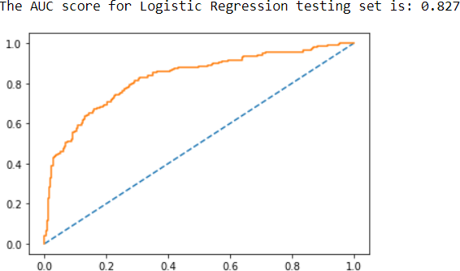

Fig 6

Fig 7
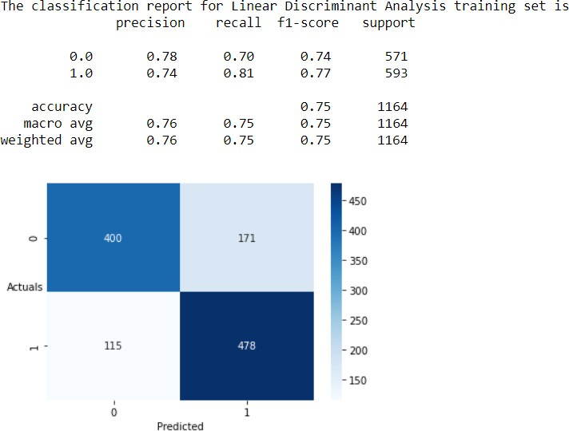

Fig 8
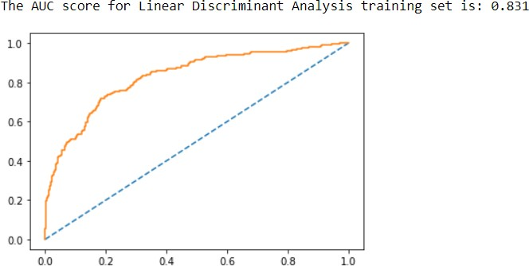

Fig 9

Fig 10
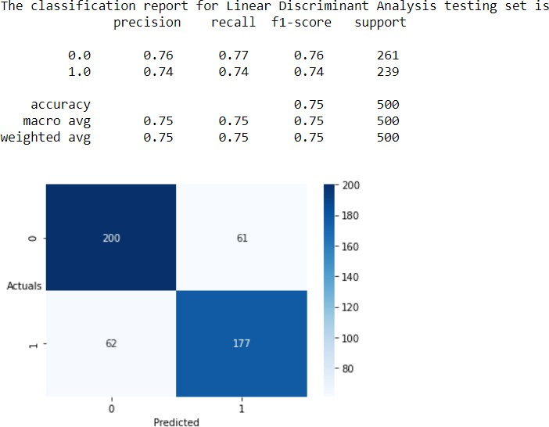
Fig 11
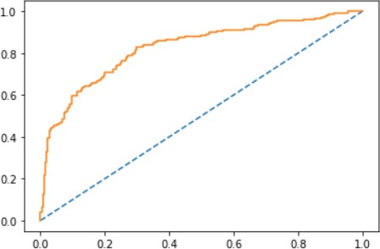

Fig 12

Fig 13
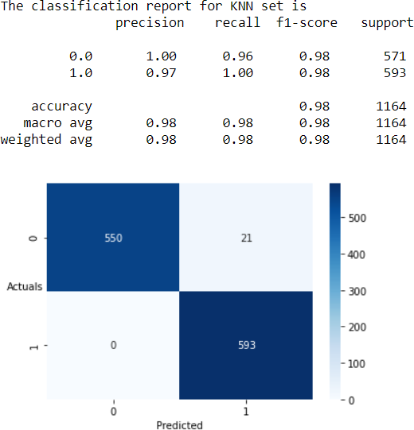

Fig 14
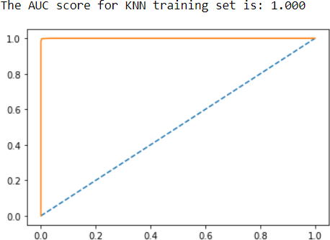

Fig 15

Fig 16
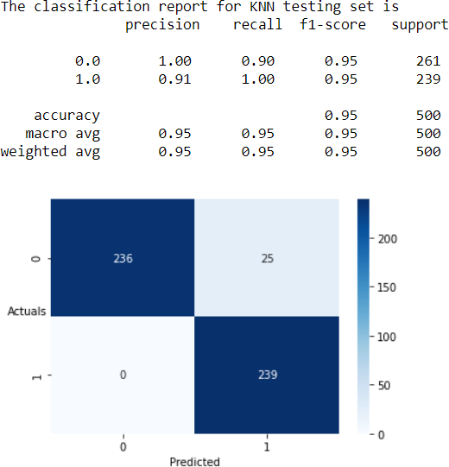

Fig 17

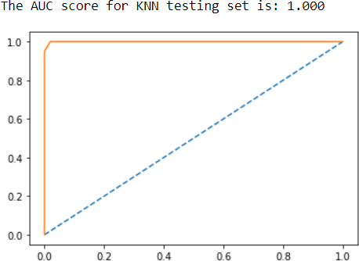

Fig 18

Fig 19
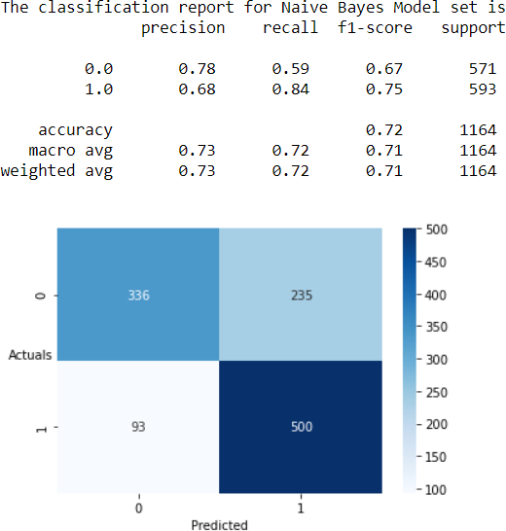

Fig 20
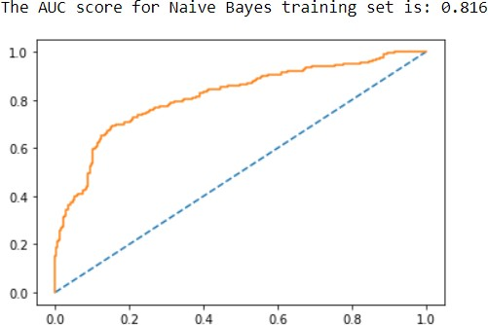

Fig 21

Fig 22
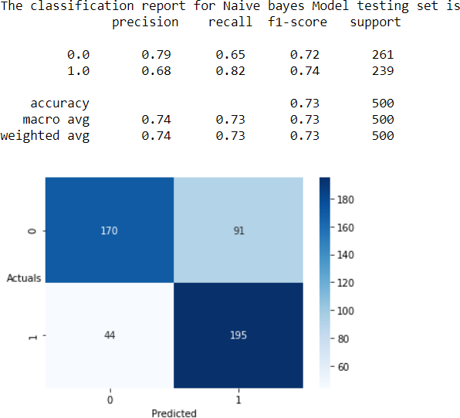

Fig 23

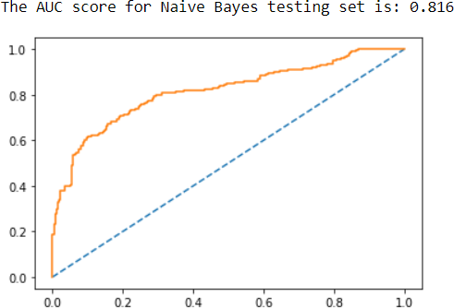

Fig 24

Fig 25
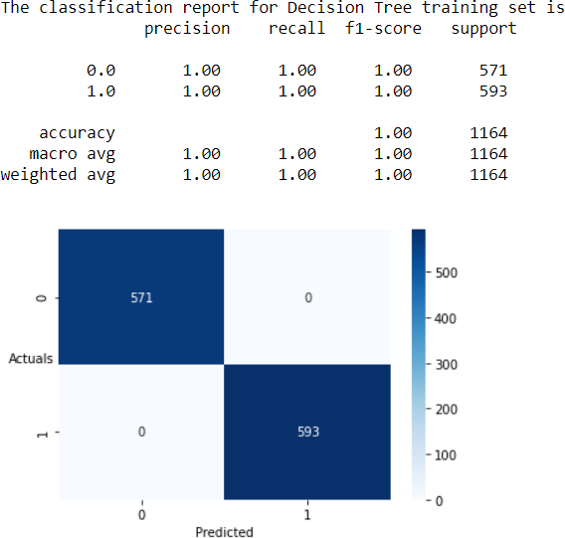

Fig 26
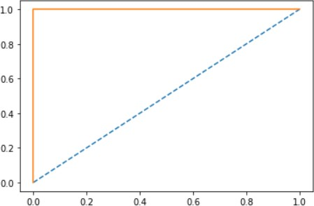

Fig 27

Fig 28
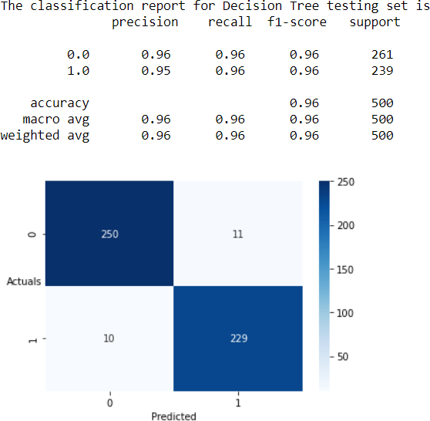

Fig 29

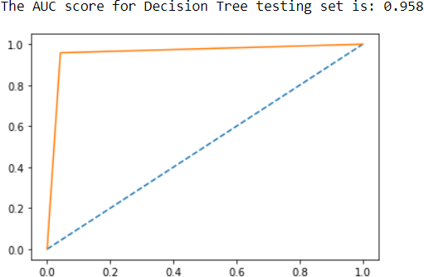

Fig 30

Fig 31
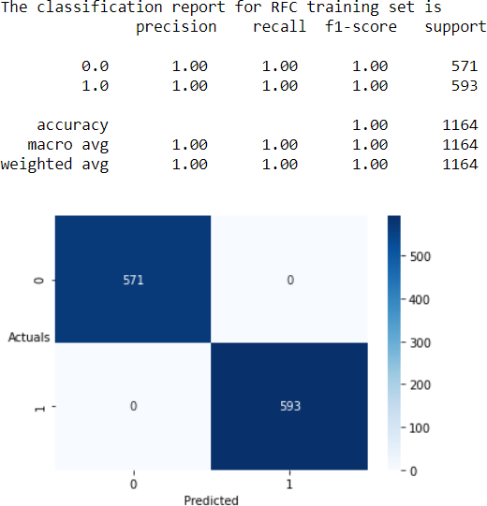

Fig 32
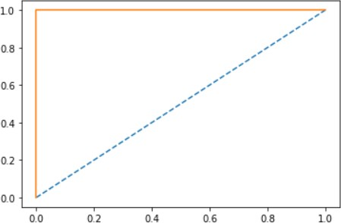

Fig 32

Fig 34
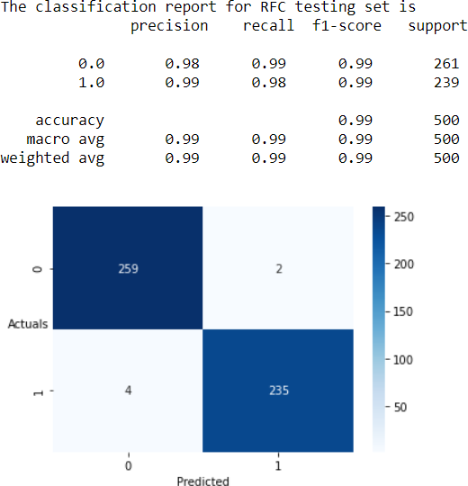

Fig 35

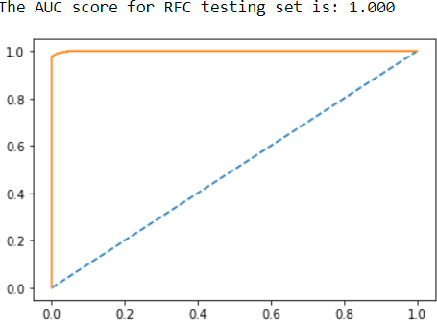

Fig 36

Bagging Training Set
Fig 37
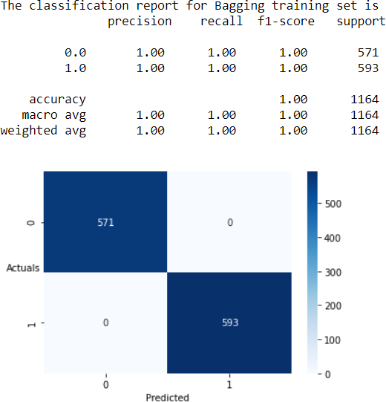

Fig 38
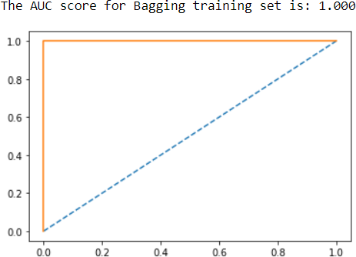

Fig 39

Fig 40
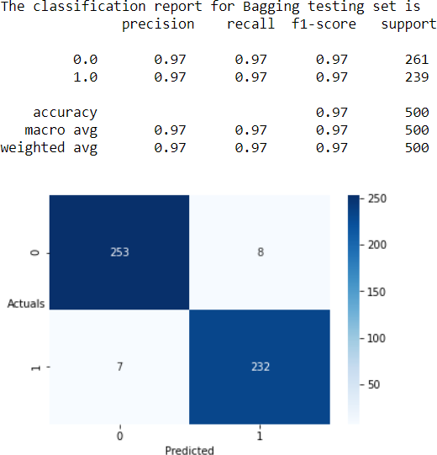

Fig 41

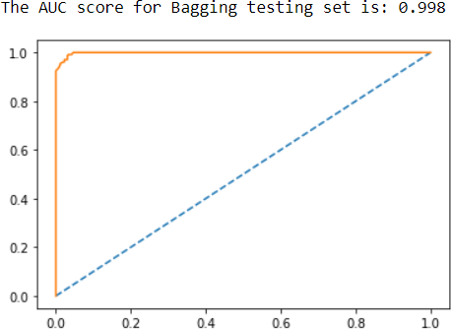

Fig 42

Fig 43
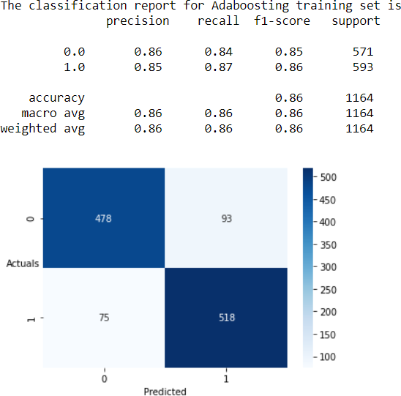
Fig 44
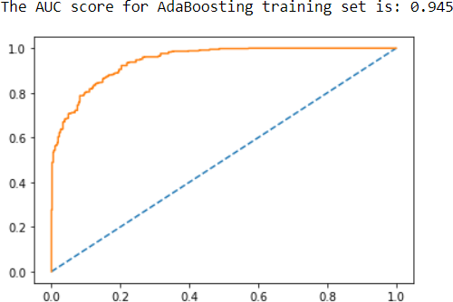

Fig 45

Fig 46
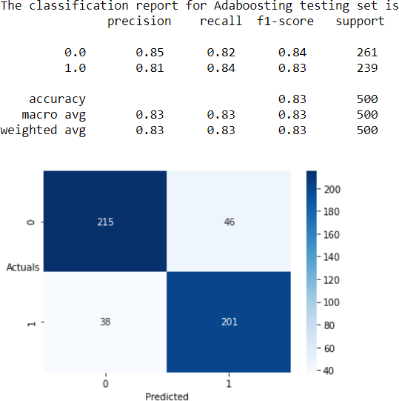

Fig 47
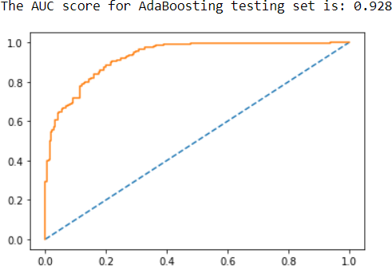

Fig 48

Fig 49
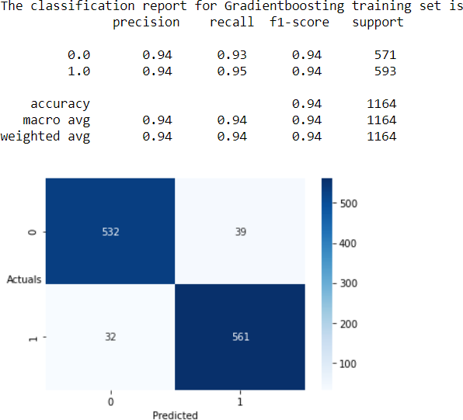

Fig 50
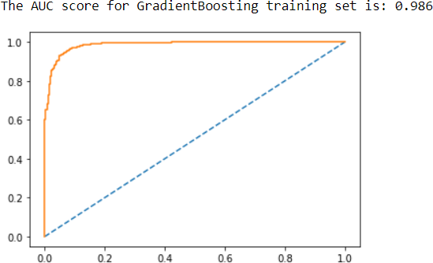

Fig 51

Fig 52
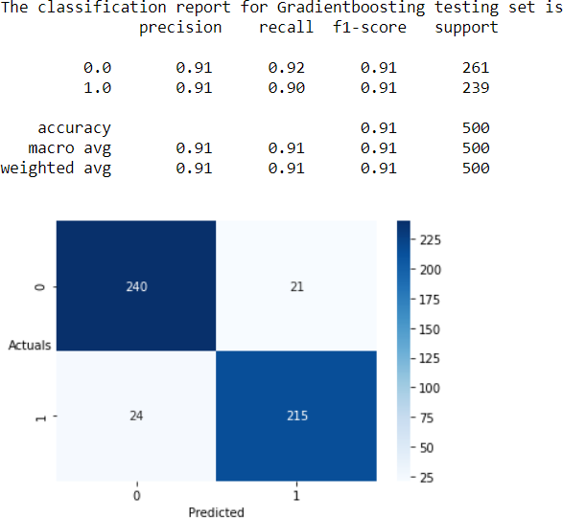

Fig 53
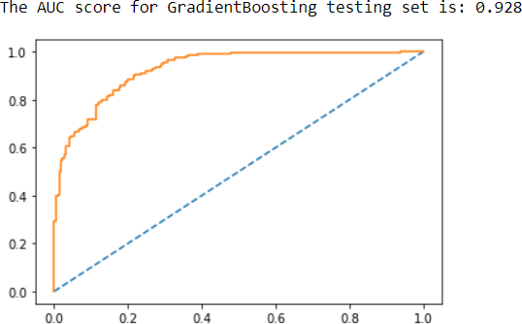

Fig 54

Model Comparison
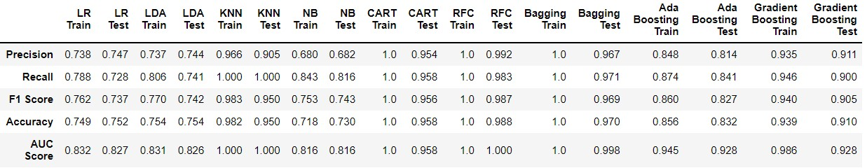
Fig 55

- In order to perform these models, the data was cleaned and unwanted variables were removed. This was followed by treatment of the imbalance in the data using SMOTE.
- After that the data was scaled using the standard scalar as there are variables in 1000’s, 100’s etc. With that, train test split was performed in which the data was divided in the ratio of 70:30 where 70% constitutes the training set.

  - Logistic Regression model and Linear Discriminant Analysis model provides very poor accuracy of 74.9% and 75.4% on train set and 75.2% and 75.4% on test set respectively. In Logistic regression it can be observed that the accuracy for test set has shown a very little improvement whereas in case of Linear Discriminant Analysis accuracy remained the same.
  - Decision Tree (CART) model and Random Forest model have provided an excellent accuracy on Training set that is 100% and applying the models to testing set, we see that the accuracy has declined a bit that is 95.8% for Decision Tree (CART) model and 98.8% for Random Forest model.
  - The AUC score of both test and train set for K- Nearest Neighbours model and Random Forest model is perfect i.e., 100%. Although, both the models are very good the recall of Random Forest model (98.3%) is slightly lower than the K- Nearest Neighbours model (100%).
  - The worst performing model in terms of all the parameters is the Naïve Bayes model which shows the accuracy of just 71.8% in train set and 73.0% in test set where as both Decision Trees (CART) model and Random Forest model have performed equally well with better AUC score, Recall and Accuracy.
  - The K-Nearest Neighbours achieved the accuracy 98.2% on training set and 98.1% on testing set. It has the Recall of 95.0% on test set.
  - Even after applying the Bagging technique the model although showed very good performance in both training as well as testing sets clocking the accuracy of 100% and 97.0% respectively.
Although, Random Forest is Test set has accuracy of 98.8% but it has produced for number of False positives which is 4. as compared to the K-nearest Neighbours having accuracy of 97.0% and producing 0 False positive cases.

Logistic Regression Training Set

Fig 56
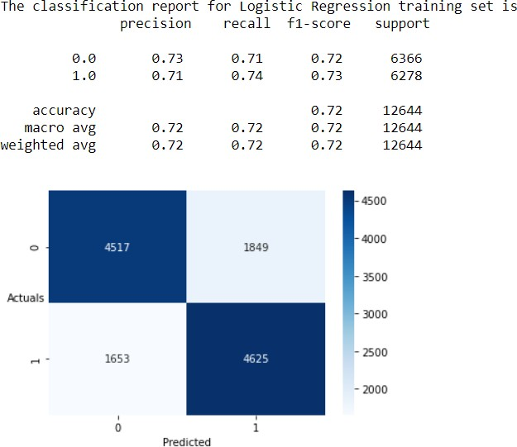

Fig 57
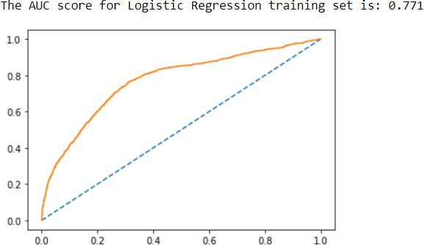

Fig 58

Fig 59
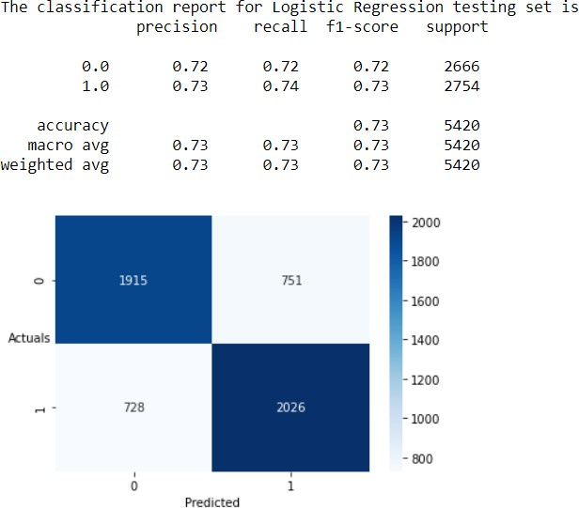

Fig 60
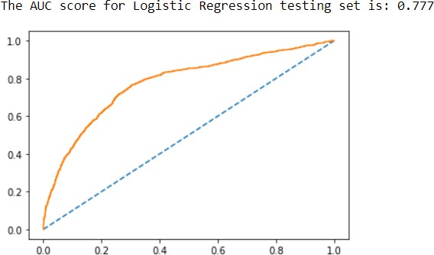

Fig 61

Fig 62
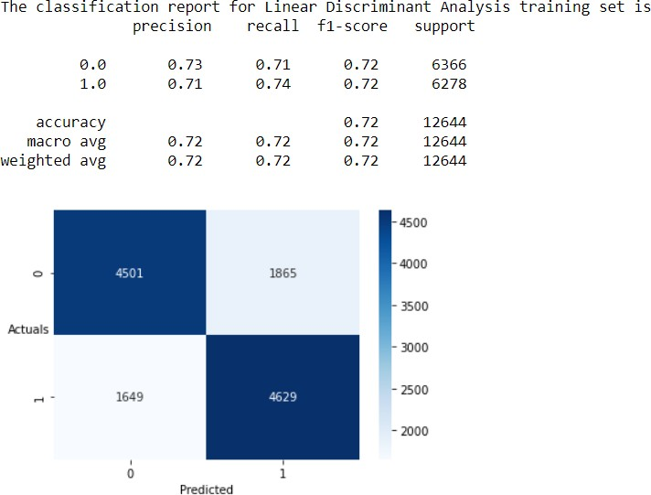

Fig 63
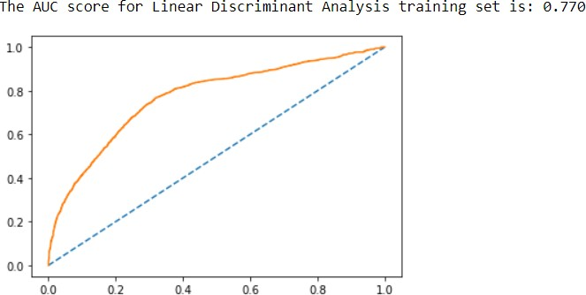

Fig 64

Fig 65
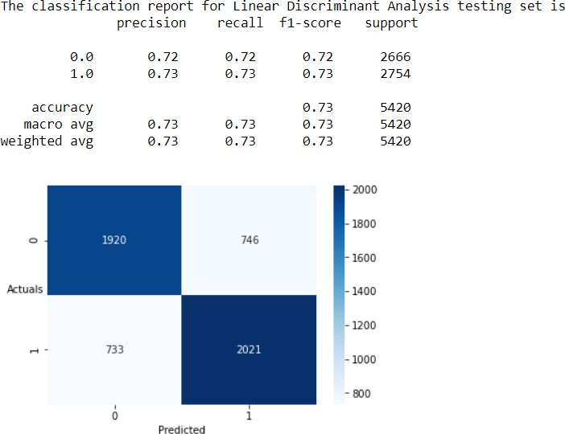

Fig 66
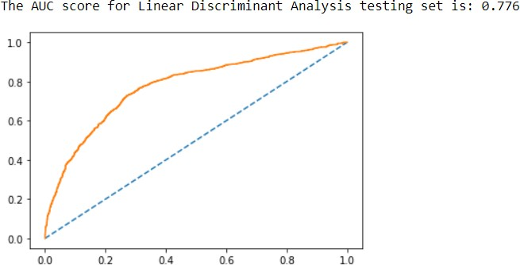

Fig 67

Fig 68
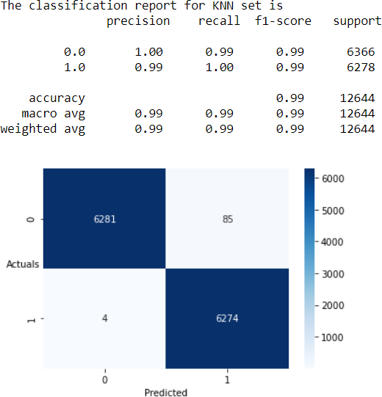

Fig 69
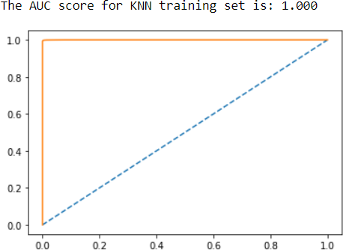
Fig 70

Fig 71

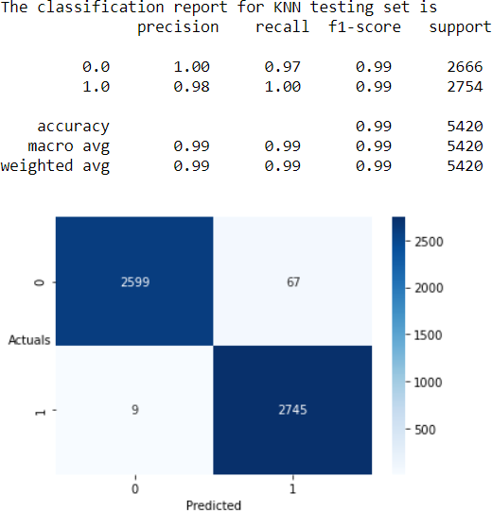

Fig 72
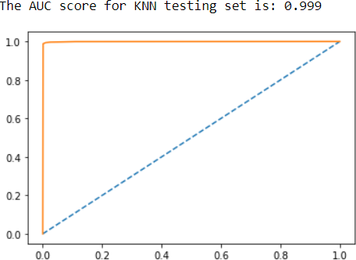

Fig 73

Fig 74
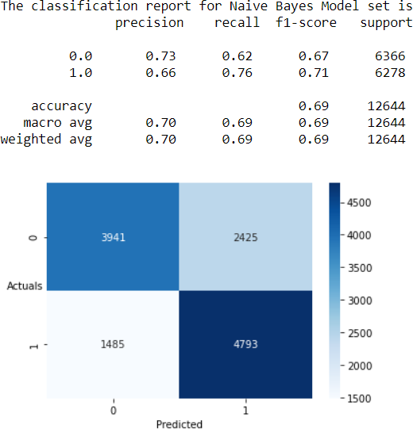
Fig 75
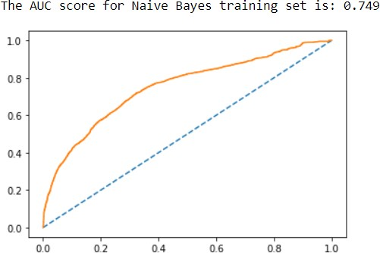

Fig 76

Fig 77
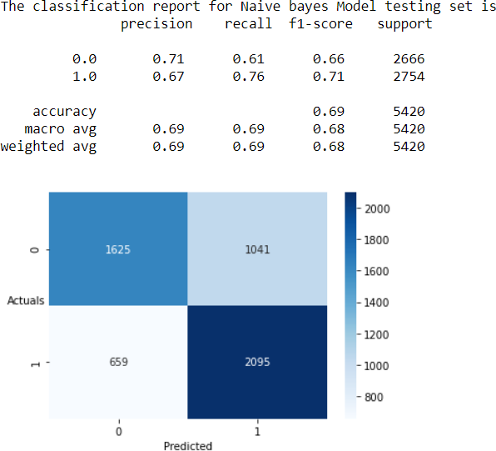

Fig 78
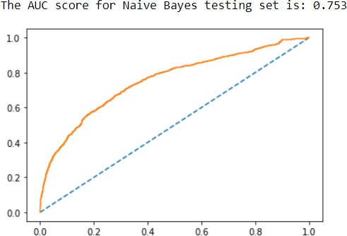
Fig 79

Fig 80
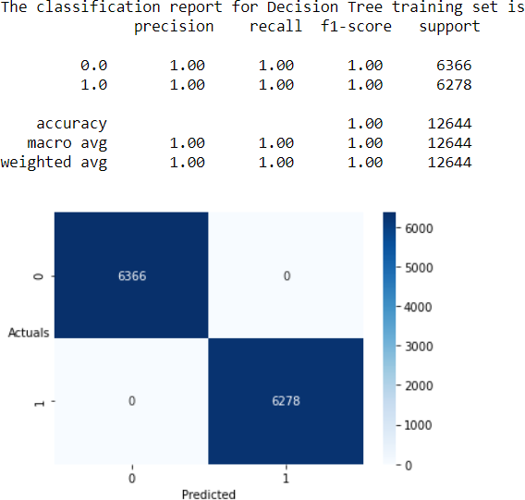

Fig 81

Fig 82

Fig 83
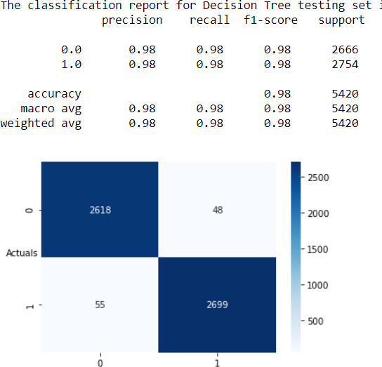

Fig 84
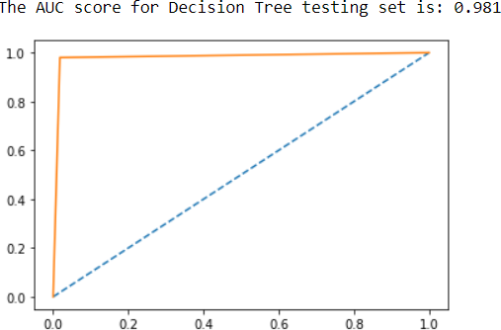

Fig 85

Fig 86
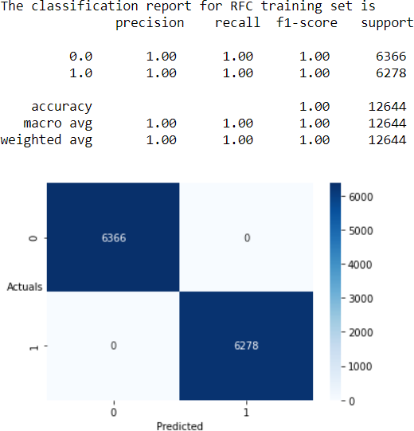

Fig 87

Fig 88

Fig 89
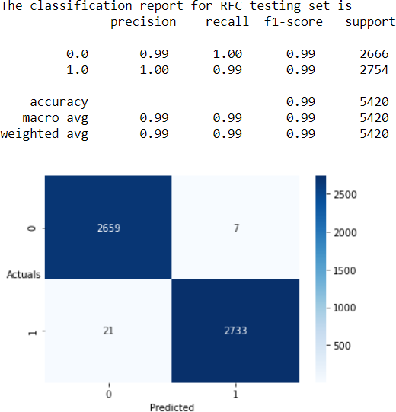

Fig 90
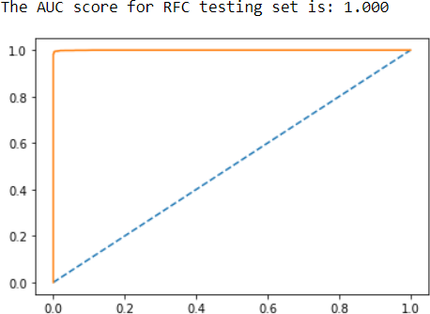

Fig 91

Bagging Training Set
Fig 92
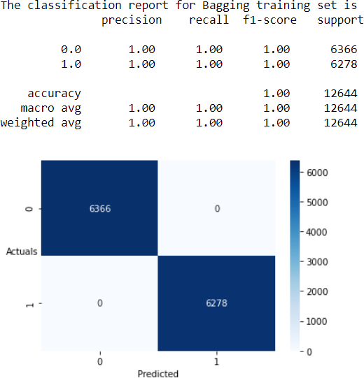
Fig 93

Fig 94

Fig 95
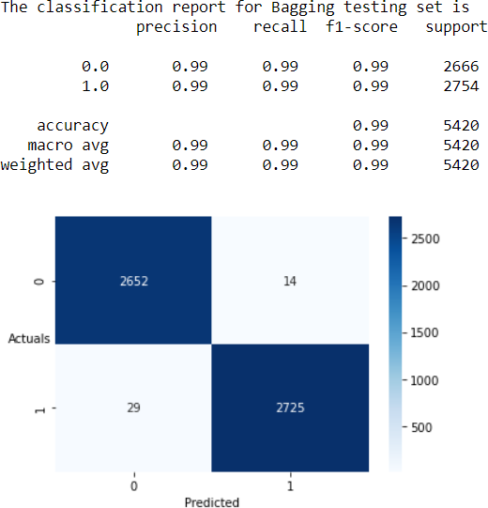

Fig 96
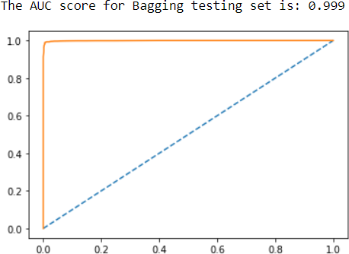

Fig 97

Fig 98
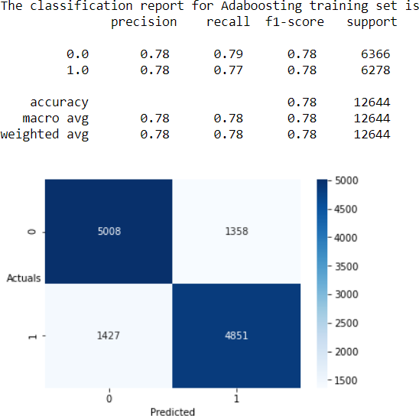

Fig 99
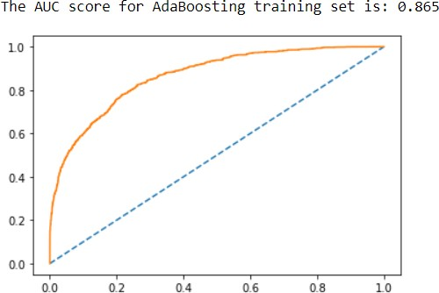

Fig 100

Fig 101
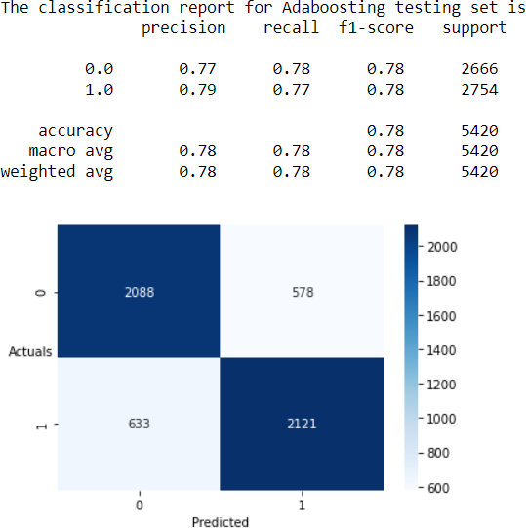

Fig 102
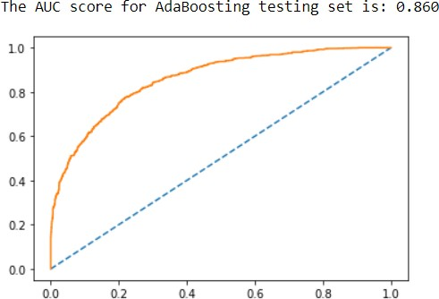

Fig 103

Fig 104
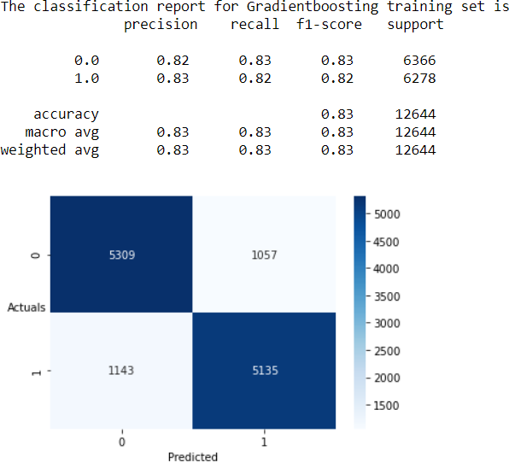

Fig 105
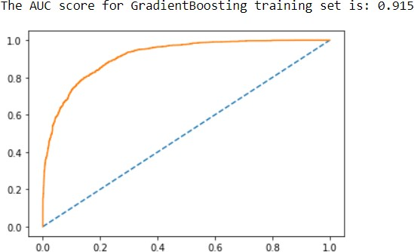

Fig 106

Fig 107
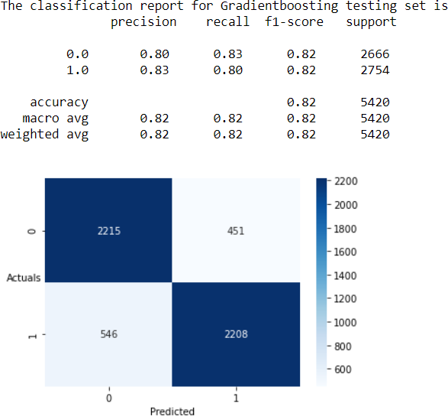
Fig 108
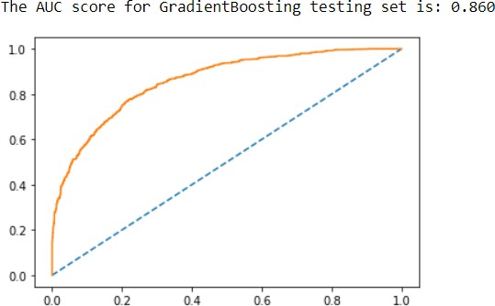

Fig 109

Model Comparison
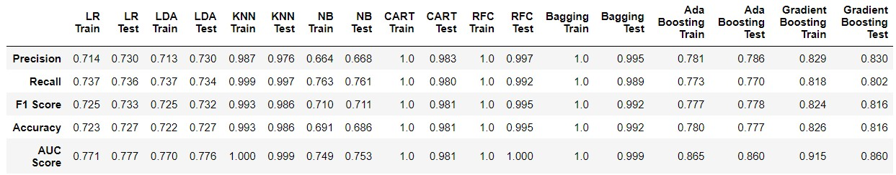
Fig 110

On comparing with the Laptop users as the number of rows or data points increases the accuracy of most of the models decreased.
- Logistic Regression model and Linear Discriminant Analysis model provides very poor accuracy of 72.3% and 72.2% on train set and 72.7% and 72.7% on test set respectively. In both the cases it can be observed that the accuracy for test set has shown a very little improvement.
- Decision Tree (CART) model and Random Forest model have provided an excellent accuracy on Training set that is 100% and applying the models to testing set, we see that the accuracy has declined a bit that is 98.1% for Decision Tree (CART) model and 99.5% for Random Forest model.
- Although, both the models are very good the recall of Random Forest model (99.2%) is slightly lower than the K- Nearest Neighbours model (99.7%).
- The worst performing model in terms of all the parameters is the Naïve Bayes model which shows the accuracy of just 69.1% in train set and 68.6% in test set.
- Even after applying the Bagging technique the model although showed very good performance in both training as well as testing sets clocking the accuracy of 100% and 99.2% respectively.
- Although, Gradient Boosting model performed better in case of Laptop using customers but for mobile using individuals the huge decline is observed in the accuracy.
Although, Random Forest is Test set has accuracy of 99.5% but it has produced for number of False positives which is 21. as compared to the K-nearest Neighbours having accuracy of 98.6% and producing 9 False positive cases.
So, in both the cases K-Nearest Neighbours is the best model.
- Applying this model having such as high Recall of can help the company identify which customers can purchase the product in the new future. Also, this helps in better reach and target the audience accordingly.
- This can also increase the traffic on the company’s site resulting in better minimizing the click per cost expense for the company.
- As, the higher the number of hits on website increases, more chances of purchasing the product also increases bringing in the surge in revenues for the company.

